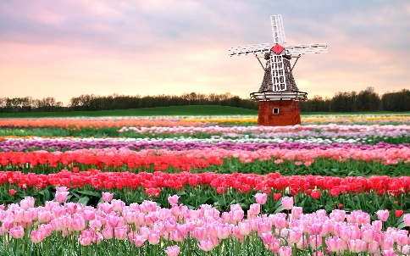

TULIP LOVERS!!! Mini-Rotary Friendship Exchange – District 6250 (Wisconsin) and the Rotary Club Uithuizen - het Hoogeland (the Netherlands) – Open to All District 6250 Rotarians.

Please read fully … contact Edwin Bos at edwin@bosdesignbuilders.com if interested. If you don’t receive a confirmation your interest has not been noted. Please resend.

What: This is a Mini-Rotary Friendship Exchange (home stay) taking place during the Rotary Club Uithuizen – het Hoogeland’s annual “To the Tulips” walk, bike and car tour weekend. There will be no official return leg. The following event website translates to English: https://www.naardebollen.nl/

When: District 6250 travel to the Netherlands as follows below. Participants are free to travel independently and spend time in the Netherlands or Europe either before or after the long weekend of the Mini-RFE.

- April 25th (Thursday) or Prior – Fly Chicago to Amsterdam.
- April 26th (Friday morning) – Train from Schiphol Airport to het Hoogeland in the Netherlands. Arrive in early afternoon.
- April 27th (Saturday) – To the Bulbs walk, bike and car tour event. Coincidentally also the national holiday “King’s Day” in the Netherlands this year.
- April 28th (Sunday) – Time with Hosts
- April 29th (Monday) – Depart for Amsterdam or elsewhere.

The only absolute requirement for the mini-RFE is that you are in het Hoogeland region by a certain time on Friday April 26th and that you don’t leave prior to Monday April 29th.

Where: het Hoogeland is in the Groningen Province of the Netherlands. In 2019, Rotary in this area hosted a full 6250 RFE. Dutch Rotarians visited us in the fall of 2019. Clubs in this area were the international partners on the La Crosse Mobile Clinic Rotary Global Grant project. We are guaranteed to see friendly and familiar faces the minute we step off the train 😊.

Who: Maximum group size TBD based on hosting capacity. Interested Rotarians, spouses and/or family members eligible. If oversubscribed / too much interest, we will use District 6250 RFE policy parameters to put the final group together. Note that the policy favors RFE novices as we want more people to experience the international in Rotary International!

How: This will be the first every District 6250 mini-exchange. Must be willing to let others organize your life and to go with the flow during the short RFE. Private travels within the Netherlands and Europe both before and after the RFE are your choice. Final District 6250 RFE group MAY meet in Wisconsin at least once prior to the trip to work out details.

Costs: Currently round-trip costs are $556 (one-stop) and $884 (direct) for Chicago – Amsterdam – Chicago. There will be train expenses and other miscellaneous expenses. Hosting during the mini- exchange will be organized by local Rotarians.

Timing: We plan to have the final group identified by the end of February 2024.

Trip Leader 6250: Rotarian Edwin Bos who is Dutch and whose family hails from this part of the Netherlands.

Please let Edwin know if interested at edwin@bosdesignbuilders.com. Questions are welcome but please realize that not all details of the trip have been worked out. Firm interest appreciated. At the end of February participants will be asked for a $250 deposit which will be fully refunded upon return. Sorry to have to do this but we need to be certain that we (and our hosts) only have seriously interested Rotarians signed up. We also need to be certain that everyone participates in the full RFE.

Map and Famous Song of Area – Mien Hoogeland by Ede Staal (in Groninger Dialect)
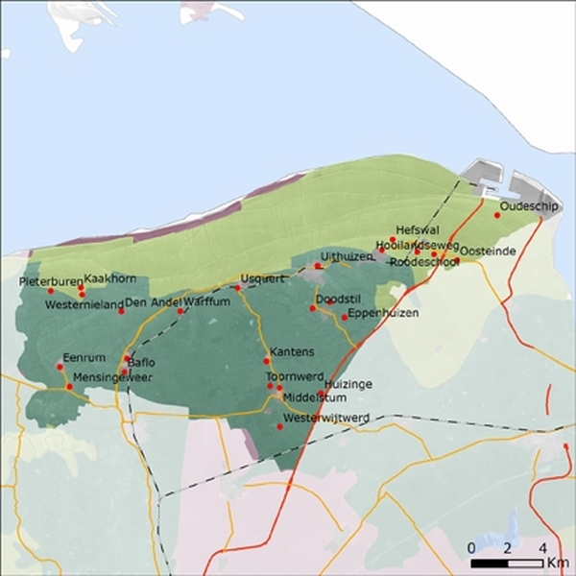

Mien Hoogeland by Ede Staal (in Groninger Dialect) - Lyrics
t Hogelaand  t Is de lucht achter Oethoezen,  t Is t torentje van Spiek,  t Is de weg van Lains noar Klooster,  En deur Westpolder langs de diek.  t Binnen de meulens en de moaren,  t Binnen de kerken en de börgen,  t Is t laand woar ik as kind,  Nog niks begreep van pien of zörgen.  Dat is mien laand, mien Hogelaand...  t Is n doevetil, n dörpsstroat,  t Is n olde bakkerij  t Binnen de grote boerenploatsen,  Van Waarvum Oskerd, zo noar Mij.  t Is de waait, t is de hoaver,  t Is t koolzoad in de blui,  t Is de horizon bie Roanum,  Vlak noa n dunderbui.  Dat is mien laand, mien Hogelaand...  t Is n mooie oavend in maai,  n Kou houst doeknekt in t gruinlaand,  Ik heb veur d'eerste moal verkeren,  En vuil de vonken van dien haand.  De wilde plannen dij ik had,  Komt sikkom niks meer van terecht,  Totdat de nacht van t Hogelaand,  n Donker klaid over ons legt,  Dat is mien laand, mien Hogelaand... | The Hoogeland  It is the sky behind Uithuizen,  It is the tiny tower at Spijk,  It is the road from Leens to Kloosterburen,  Through the West Polder along the dyke.  It is the windmills and the canals,  It is the churches and the farms,  It is the land where as a child;  I didn’t understand yet about pain and sorrow.  That is my land, my Hoogeland …  It is a dovecot, a village street,  It is an old bakery,  It is the large country estates,  From Warffum, Usquert, to Uithuizermeeden.  It is the wheat, it is the oats,  It is the flowering rapeseed,  It is the horizon by Ranum,  Just after a thunderstorm.  That is my land, my Hoogeland …  It’s a beautiful May evening,  a cow coughs in the meadow;  I made love for the first time,  and felt the sparks from your hand.  The wild plans that I had,  Might come to nothing at all,  Until the night of the Hoogeland  lays a dark blanket over us,  That is my land, my Hoogeland …

